1. What is **component** is means:

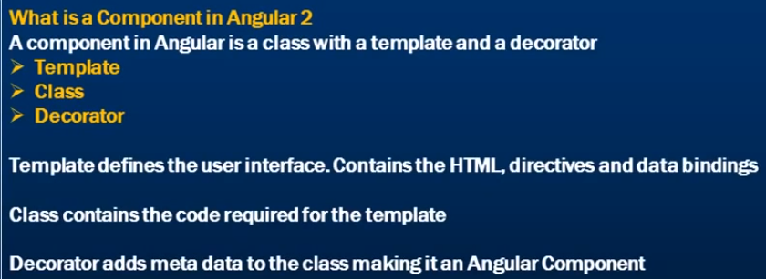

**decorator** options:

@component({

templateUrl, providers, styleUrl, style, inputs, interpolation...etc

})

**Class:** export class

2.**directives**- ngFor, ngIf...etc

3.**observable** vs **promises**—

Observable- is like a in video steams, chat ...ect, because their multi time communications happenings, so observable is good way to use. Where as promise is like single way return 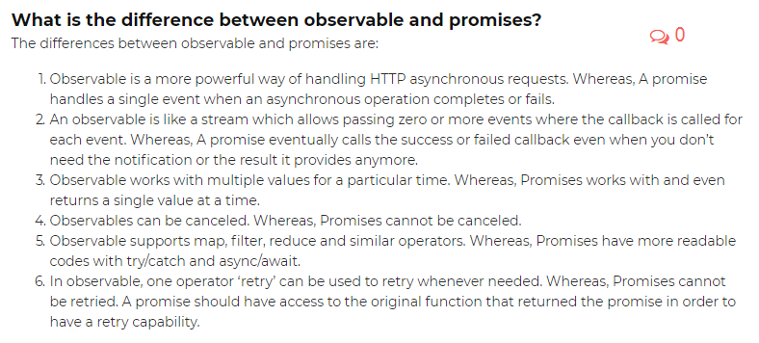

4.**life cycle hooks**

->life cycle means from start to end(destroy)- life cycle of hook. We have to import it from angular/core 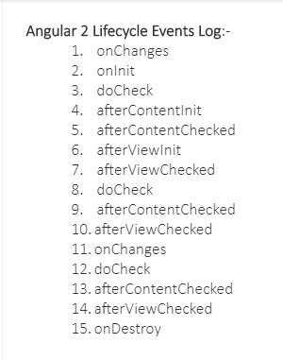

**Priority:** Constructor > **ngOnChanges>** ngOninit > ...etc

ngOnChanges, ngAfterContentChecked, ngOnInit, ngAfterInit, ngDoCheck, ngAfterView Checked, ngAfterContentInit, ngDestroy

5. ngOninit vs constructor

**Constructor:** is a default method when ever initiated new class

**ngOninit-**life cycle hook- ongoing components

here we have to add ‘implements Oninit’ extend of the export class 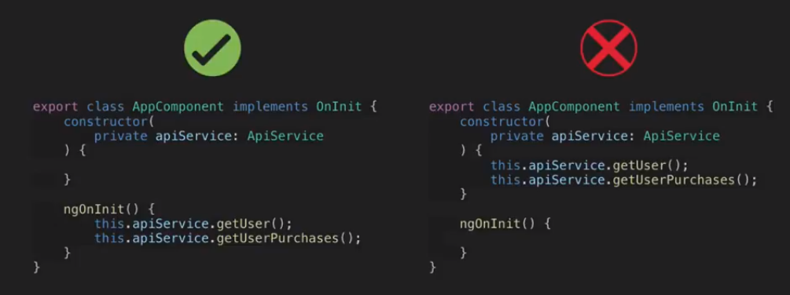

6.implements vs

7.Routing

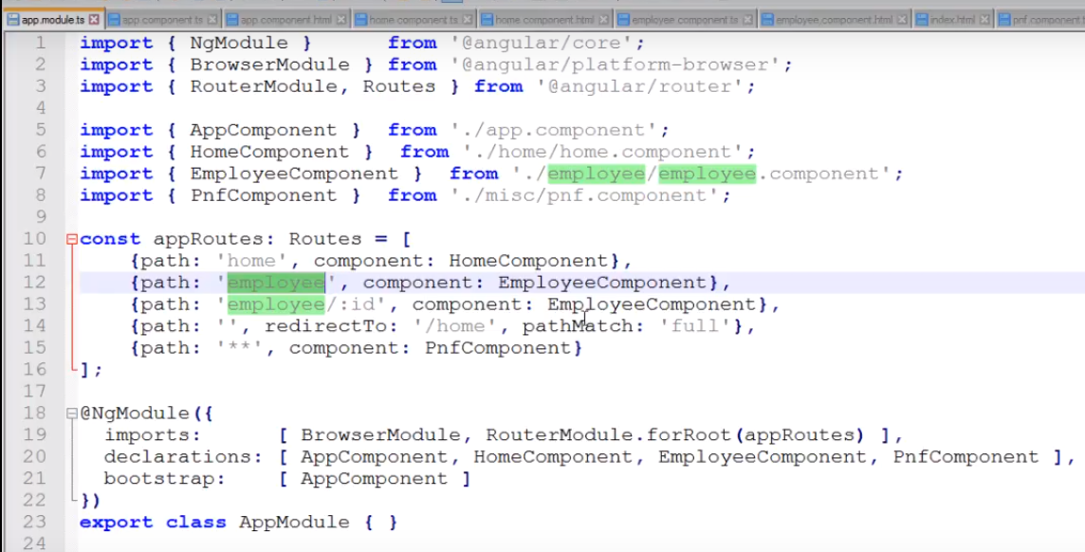

8. Angular bootstrapped:

9.Event Binding: normal ye, like click event use hide or show on div ex.:

10. building blocks of Angular

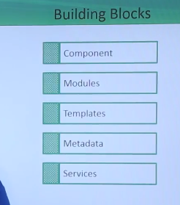

[11. @input](mailto:11.@input)

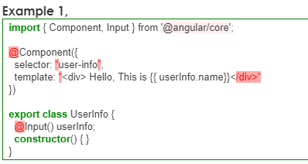

12. @outpu:

13.New Things in Angular 7 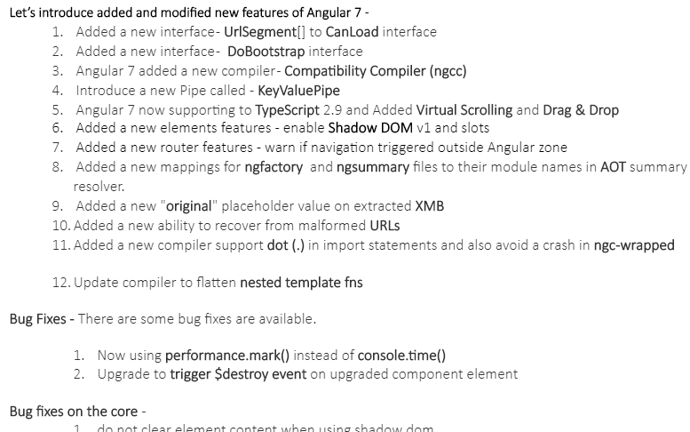

14. How to communicate between component to component

15. what is Traceur compiler?

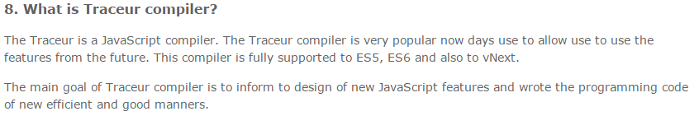

16.diffrent b/w angular 2 component vs directives 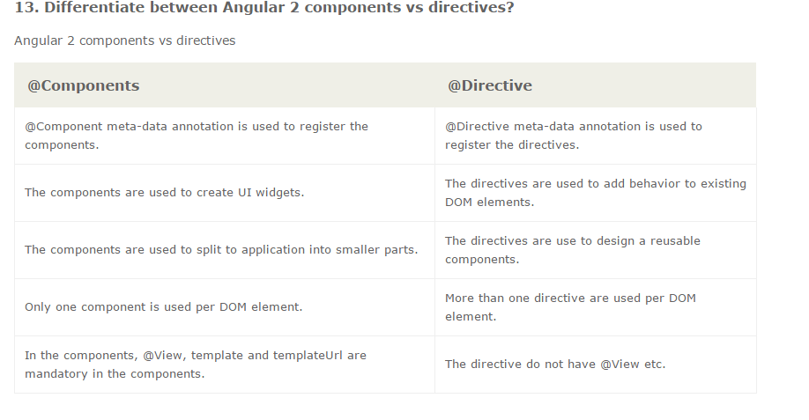

17.Route params

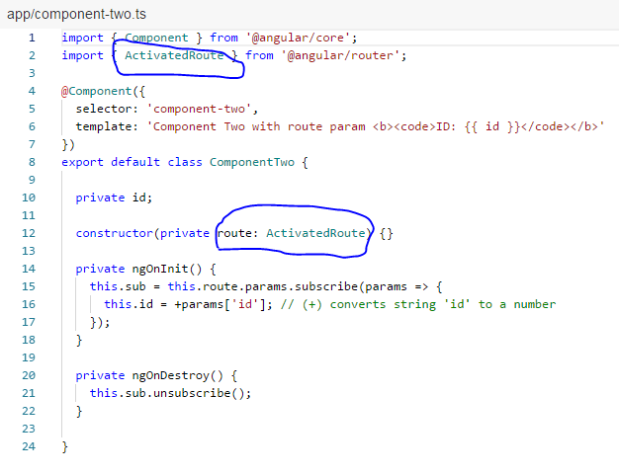 <https://embed.plnkr.co/EmL9snk036MvxZsNS4bc/>